**1.(Solid Rectangle)**

**Exercise**

* **Print the pattern using for loop**



**Approach:**

**So here we did like this**

**Row range:0-4**

**Column range:0-5**

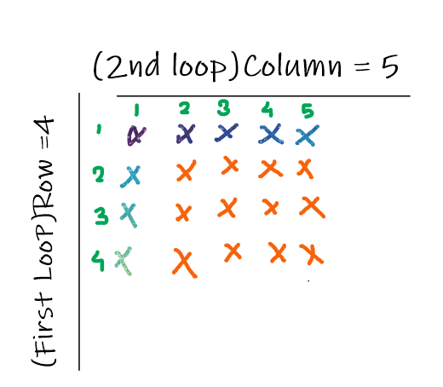

**Solution 👇**

**Java :**

**public class code_xam {**

**public static void main(String[] args) {**

**for (int i = 1 ; i <=4 ; i++){**

**for (int j = 1; j <=5 ; j++){**

**System.out.print("*");}**

**System.out.println();**

**}**

**}**

**}**

**output:**

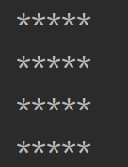

**Python :**

**for i in range(1, 5):**

**for j in range(1, 6):**

**print("*", end=" ")**

**print()**

**output:**

